12553 19th Ave Solar Project

Report Prepared By: Karl Oleson

Report Date: 9-14-23

# Overview

Project Description: Residents would like solar panels on their roof. They would like an estimate on:

1. How much energy they can harvest
2. What portion of their energy needs can be filled by solar
3. Cost of an installation and payback period

Site and Customer Information**: Single story** residence in a Seattle neighborhood with large trees on customer’s and neighbor’s properties. Connected to the grid with existing 125Amp central circuit breaker. Customers are planning on buying an electric car but otherwise use the average electricity of an American household. Coordinates: 47.72093, -122.30954

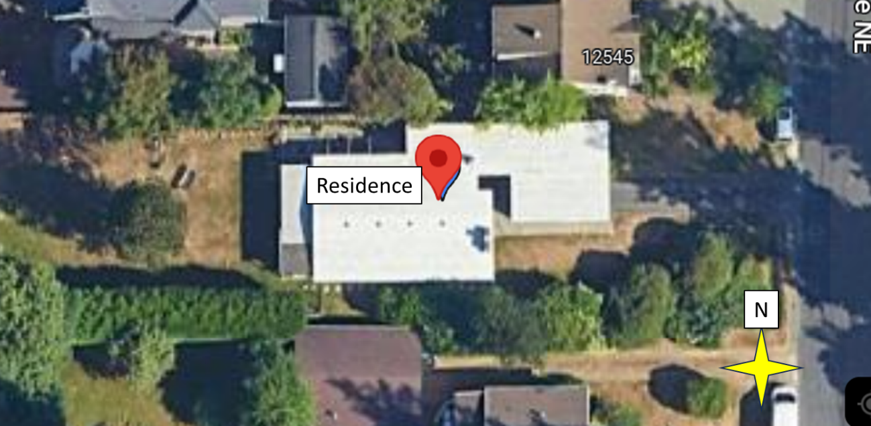

Figure 1: Google Maps Photos of the Site.

Executive Summary: A tree on the southern portion of the property and two rows of hedges are recommended to be removed/replaced before installation. These features currently cause the roof to experience large dynamic shading patterns throughout the day. Additionally, an upgrade to the breaker box is recommended pending approval from the local utility company.

Should that be allowed, a system of 33 Silfab 370W panels with Enphase IQ7+ microinverters is recommended. This will start producing approximately 13.3MWh its first year, approximately 86% of their energy needs the first year with the electric car. The system is projected to payback the cost to the homeowners in 12-13 years.

Figure 2: Estimated energy output of recommended system. The installation starts out at an estimated production of 13.36 MWh per year and will reach a production of approximately 11MWh at 30 years.

Figure 3: Recommended 33 panel installation with southern tree and hedges removed.

Contents

Overview 1

Project Description 1

Site and Customer Information 1

Executive Summary 2

Simulation Methodology 4

Estimation Software 4

Site Simulation 4

Sizing Methodology 4

Simulated Site Details 4

PVsyst Parameters: 6

Project Name 6

Geographical Site Parameters: 6

Orientation Parameters 6

Initial Shading Analysis of Current Site 6

Recommended Site Change Based on Shading Analysis 8

Panels 8

Inverter(s) 8

Circuit Breaker Considerations 9

Detailed losses - Aging 9

Horizon 10

Recommended Panel Number and Arrangement 11

Economic Considerations: 12

Expense Values Used: 12

Expenses Background Information: 13

Third Party Estimated Project costs 14

Math used to Develop Expense Values: 15

Simulation Results 16

Detailed Energy Loss Analysis 16

CO2 Diversion 17

Year-by-Year Economics 18

# Simulation Methodology

Estimation Software**:** PVsyst 7.4

## Site Simulation

Sizing Methodology: Try to fit as many panels possible on the south facing roof without exceeding the projected energy usage of the household. Panels should also ideally experience shading only under 200W/m2 illumination.

### Simulated Site Details

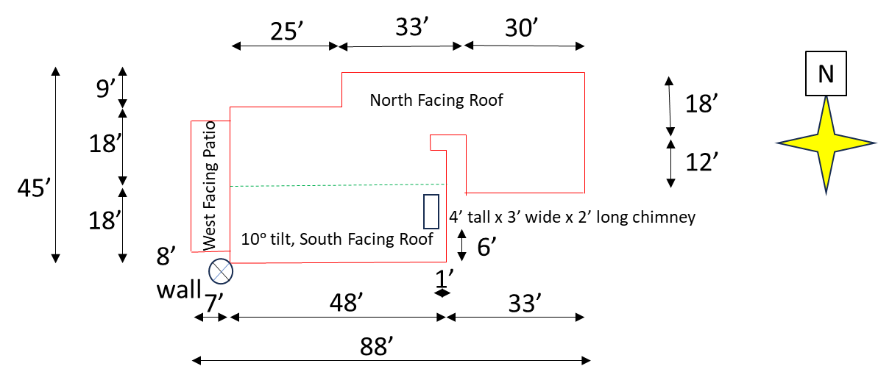

Figure 4: Site drawing of house.

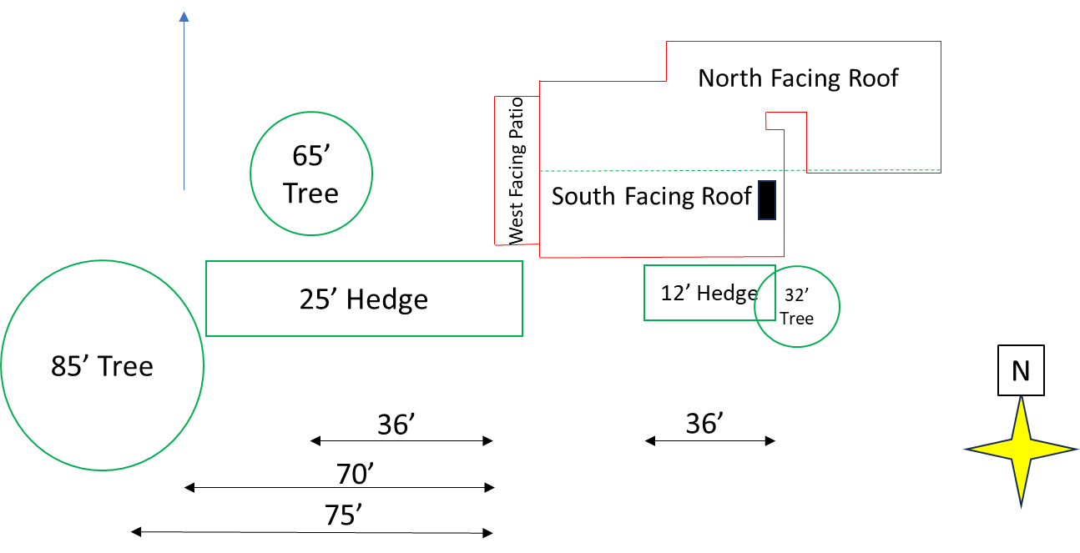

Figure 5: Site drawings of house and relevant shading concerns.

Figure 6: PVsyst existing site construction

Figure 7: PVsyst existing site construction compared to Google Maps photo.

## PVsyst Parameters:

Project Name: 12553 19th Ave NE

### Geographical Site Parameters:

* Site Name: 12553 19th Ave NE Seattle
* Meteo data Import: NREL NSRDBA screenshot of a computer

  Description automatically generated

Figure 8: Site radiation, temperature, and wind speed information per month and over the course of a year.

* Site File 12553 19th Ave NE Seattle_NREL_TMY.SIT
* Meteo File: 12553 19th Ave NE Seattle_NREL_TMY.MET
* File Name: 12553 19th AVE NE_Project

Orientation Parameters:

* Plane tilt: 10ᵒ (-9.7% loss with respect to optimum due panels being parallel to roof)
* Azimuth: 0ᵒ

### Initial Shading Analysis of Current Site

* Representative Day: September 30th
* Times of the day to be concerned about shading: 7:30 a.m. to 4:30 P.M.

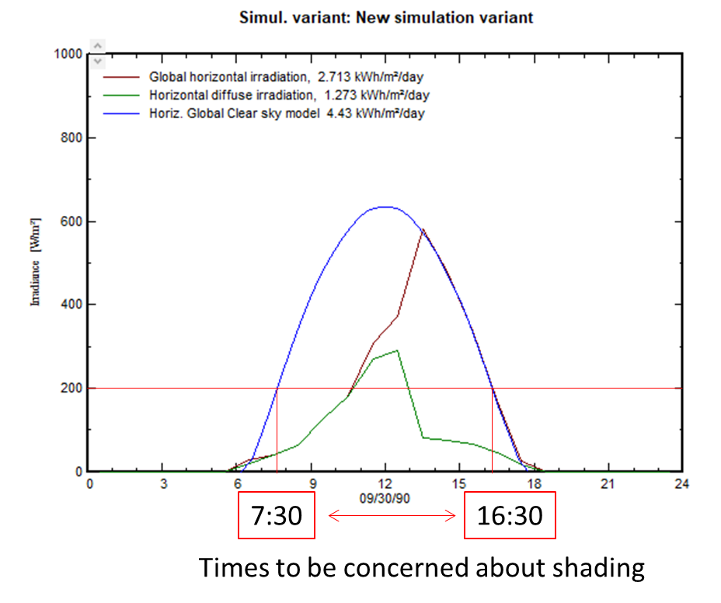

Figure 9: September 30th irradiance values over the course of the day.

Figure 10: Shading concerns at different times of the day September 30th: a) 7:30 a.m., b) 8:00 a.m. c) 4:00 p.m. The chimney, southern tree, and two hedges create dynamic shading pattens.

### Recommended Site Change Based on Shading Analysis

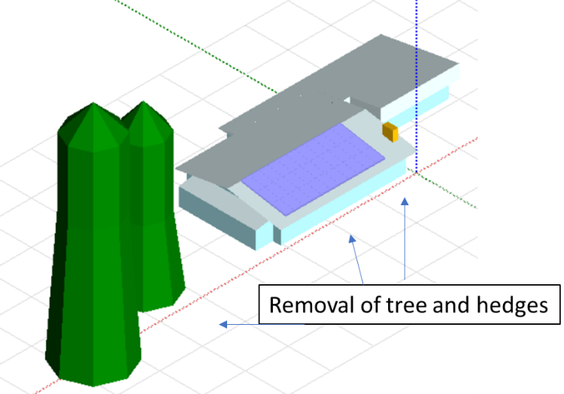

Figure 11: Recommended site changes. Recommended to remove the southern tree and hedges. Alternative landscaping that will not grow taller than the roof (7 feet) is recommended.

### Panels

Silfab panels manufactured locally in Washington state have been selected. The Silfab 370W Solar Panel 120 Cell SIL-370-HC will be used since panels for $0.49 per kWh were found (*before tax and shipping) on A1SOLARSTORE.com in September 2023.

<https://a1solarstore.com/silfab-370w-solar-panel-120-cell-sil-370-hc.html?utm_source=google&utm_medium=cpc&utm_campaign=Pmax_SolarPanel_Only%20desktop&utm_content=top_keywords_2&utm_term=&gad=1&gclid=CjwKCAjwjaWoBhAmEiwAXz8DBX1NclTyO6Qg6E94MGKwh3L3l6A8PsZuaymcfMkJFoito1Qd5_tyPRoC9LwQAvD_BwE>

### Inverter(s)

Three inverter options were investigated. Enphase IQ7+ Microinverters (List Price $5,428.50 per 33 units) were compared to a low cost string inverter option, Growatt, 11.4kW Grid Tie Inverter MIN11400TL-XH-US (List Price $1,496.00) and a TS-11.4K-US string inverter + Tigo TS4-A-F power optimizer system from Tigo ($3,748.57).

<https://enphase.com/store/microinverters/iq7-series/iq7plus-microinverter>

<https://signaturesolar.com/shop-all/grid-tie/inverters/>).

<https://www.invertersupply.com/index.php?main_page=product_info&products_id=203133&gad=1&gclid=CjwKCAjwjaWoBhAmEiwAXz8DBYoX-k3gI07c7oYvLScMlK5aGnsZA71wueuqLSyQIY_pG4_wo1EKvRoC-3EQAvD_BwE>

https://www.solar-electric.com/tigo-ts4-a-f-pv-rapid-shutdown.html?gclid=CjwKCAjwjaWoBhAmEiwAXz8DBQMHdyMq3qyMLwV9E63Btl1jl5hQS6lR2h5VvfzrDLN4H4F3MQHfPxoCq50QAvD_BwE

PVsyst predicts an increase in energy of 1900kWh a year with the microinverter route and 1000kWh for the optimizer based system over the string inverter. In Washington with electricity prices approximately $0.13 per kWh this would equate to an additional savings of $247 and $130 per year respectively. Both the microinverter and optimizer systems could recoup their investment for 20+ year systems.

The cheap Growatt inverter option will be the most economical option for a system expecting to last 10-15 years. However, with the existing shading concerns on the property the microinverter and optimizer routes will likely lead to several years longer system lifetime and a safer system overall. This is born out in the corresponding warranties for the equipment. Growatt only provides a 10 year warranty. The Tigo inverter has a 12.5 year warranty. The Enphase inverters have a 25 year warranty.

With the differences in warranty in mind and an eye on a long standing installation, the Enphase microinverter system is recommended.

### Circuit Breaker Considerations

The amperage of the main breaker switch inside the breaker box will dictate how much solar can be installed in a given jurisdiction. A table with rules of thumb are provided by Enphase and are shown below. The IQ7+ inverter has the same power output as the IQ8PLUS option and it is therefore expected that the same number of these inverters can be used as the IQ8PLUS.

Figure 12: Enphase’s maximum number of recommended microinverters for a given breaker size.

https://www.yourenergysolutions.com/solar/inverters/enphase/

With the existing 125A circuit breaker, this installation would likely be restricted to ~13 panels. Upgrading the panel box to 200A or 400A should be possible but would require confirmation with the local utility company. According to solarbook.pickmysolar.com the price for this upgrade is normally $1,500-$2500 and is eligible for tax credits.

### Detailed losses - Aging

Aging losses are factored in based on the warranty information provided in the data sheet for the panels as shown below. Specifically, a loss of 17.4% is assumed after 30 years. Further information from the Silfab data sheet is entered in the warranty information. Standard default parameters are used for the other losses such as soiling and module quality.

Figure 13: Warranty information from Silfab data sheet.

Figure 14: Warranty information added into PVsyst.

Figure 15: Degradation Loss input in PVsyst.

### Horizon

The default horizon values are used in this case. The house is at the top of a hill with minimal other relevant features not included in the shading analysis.

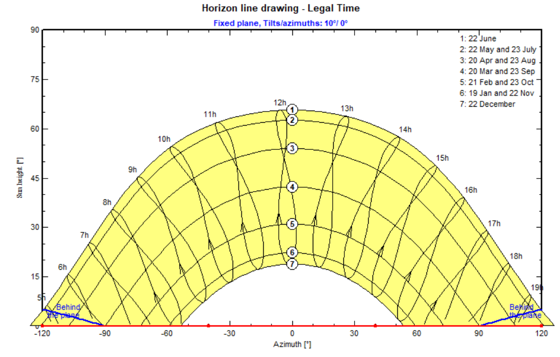

Figure 16: Horizon result for the site. No major horizon limiting features at the site excluding vegetation.

## Recommended Panel Number and Arrangement

The south facing roof can fit 3 rows and 13 columns of 370W panels in portrait configuration. The trees, hedges, and chimney on the east side of the roof create significant shading concerns. Due to the chimney, it is recommended that only 11 columns be installed on the west side of the roof. The lowest two rows experience significant shading from the eastern tree and hedges. With removal of the eastern tree and hedges a 3 row system can still be recommended. Otherwise a single row of 11 panels at the top of the house is recommended. We will continue with the removed tree/hedges option for now.

According to Seatle City Light, “While any excess production from month to month will carry over as a kWh credit on your utility bill (net metering), you will not want to install a system that produces more than 100% of your power needs annually as the utility will not reimburse you for the excess power produced at the end of the year.”

The EIA reports the average annual electricity consumption for a U.S. home is 10.632 MWh a year and energysage claims an average EV uses 4.9MWh a year. This places the home at an expected energy usage of 15.5MWh. PVsyst estimates that the first year production of such a system will be 13.36 MWh. This system produces less than 100% than the expected energy usage of the household and is a reasonable fit.

<https://www.eia.gov/tools/faqs/faq.php?id=97&t=3>

https://www.energysage.com/electricity/house-watts/how-many-watts-does-an-electric-car-charger-use/

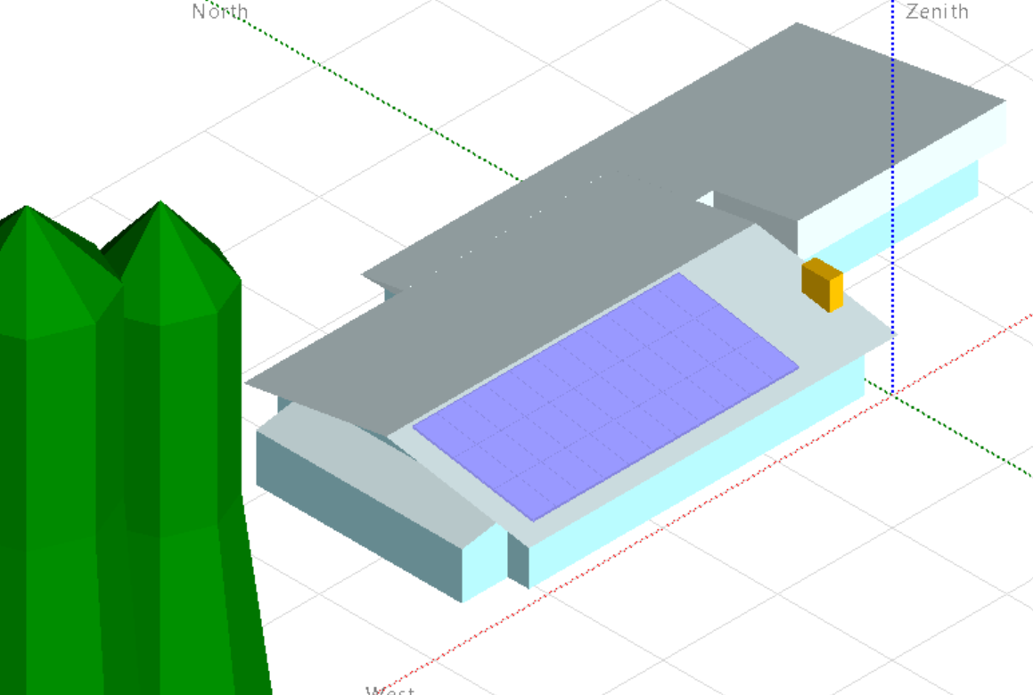

Figure 17: Recommended installation assuming a 400 Amp circuit breaker can be installed. 33 370W Silfab panels on the west side of the south facing roof parallel to the roof.

## Economic Considerations:

### Expense Values Used:

Figure 18: Costs input into PVsyst. This installation before rebates is expected to cost about $37,000.

Figure 19: For this simulation we will assume the home owner can pay for the expense out of pocket. 30% subsidies decrease the net cost to the homeowner by approximately $11,000.

### Expenses Background Information:

**NREL:** According to NREL’s “U.S. Solar Photovoltaic System and Energy Storage Cost BenchMarks, With Minimum Sustainable Price Analysis Q1 2022”, the following are reasonable estimates for some of the costs of a solar panel system:

* Structural BOS: $31.5/m2 (Includes flashing for roof penetrations and all rails and clamps.
* Electrical BOS: $43.7/m2 + $1,231 (Includes conductors, switches, combiners, and transition boxes, as well as conduit, grounding equipment, monitoring system or production meters, fuses and breakers).
* Installation labor: 0.56 hours/m2 for module and racking installation at $24.00/hour (national average construction laborer)
* Electrical Installation: $0.51 hours/m2 for electrical installation at $38.15/hour (national average electrician)
* Permitting inspection, and interconnection: $1,628 per system installation (Completed and submitted applications, fees, design changes, and field inspection).
* Sales and marketing: $3,139 per system installation (Initial and final drawing plans, advertising, lead generation, sales pitch, contract negotiation, and customer interfacing)
* Overhead: $2,060 (Rent, building, equipment, and staff expenses not directly tied to PII, customer acquisition, or direct installation labor).
* Profit: 17% (Fixed percentage margin applied to all direct costs, including hardware, installation labor, sales tax, installation, and permitting fees).

**solaractionalliance.org:** According to solaractionalliance.org, a typical solar installation has the following breakdown of costs:

Figure 20 : Breakdown cost of solar panel systems from <https://solaractionalliance.org/residential-solar-panel-cost/>

**blog.gogreensolar.com**

According to blog.gogreensolar.com, the typical solar installation has the following breakdown of costs:

https://blog.gogreensolar.com/solar-panel-installation-cost-breakdown

### Third Party Estimated Project costs

**NREL**

According to NREL, the average installed system cost for solar was $3.15 per watt for residential PV before rebates. Thus this 12.2kWh system will be around $38,552 before rebates. Potentially $27,000-$28,000 after 30% rebates.

Figure 21: Cost of residential and utility-scale PV according to NREL <https://www.nrel.gov/solar/market-research-analysis/solar-installed-system-cost.html>

**Forbes Home**

Forbes Home claims that the average cost for a 6-kWh system with the 26% Federal Tax Credit applied costs $10,309 in 2023. So this 12.2 kWh system should approximately $28,549.10 before tax credits, and $19,984.37 after tax credits.

https://www.forbes.com/home-improvement/solar/washington-solar-incentives/#:~:text=Yes%2C%20Washington%20residents%20benefit%20from,unfortunately%2C%20no%20longer%20taking%20new

https://www.forbes.com/home-improvement/solar/cost-of-solar-panels/

**MarketWatch.com**

According to marketwatch.com, the average cost of a solar installation is $3 per watt. So this installation should cost approximately $36,630 before tax credits, and $25,641 after 30% tax credit. (370W per panel * 33 panels *$3 = $36,630).

[www.marketwatch.com/guides/solar/solar-panel-cost/#:~:text=Based%20on%20our%20survey%20of,upward%20of%20%2425%2C000%20per%20installation](http://www.marketwatch.com/guides/solar/solar-panel-cost/#:~:text=Based%20on%20our%20survey%20of,upward%20of%20%2425%2C000%20per%20installation)

**Consumeraffairs.com**

According to consumeraffairs.com, the average cost of a solar installation is $2.50 per watt. So this installation should cost approximately $30,525.00 before tax credits, and $21,367.50 after 30% tax credit (370W per panel *33 panel * $3 = $30,5325.00)

<https://www.consumeraffairs.com/solar-energy/how-much-do-solar-panels-cost.html>

### Math used to Develop Expense Values:

Panel area: 62m2

10.25% Sales Tax in Seattle 10.25%

Solar Panels price + shipping (5%): 33 panels *370 watts * $0.49 per watt * 1.05 (shipping) = $6,282.05

EnPhase inverter price +shipping(5%): $164.50 per inverter * 33 inverters *1.05 (shipping)= $5,699.93

Structural BOS: $31.5*62m2 = $1,953.00

Electrical BOS: $43.7*62 m2 +$1231 = $3,940.40

Breaker Box Upgrade: $2,000

Installation Labor: 0.56 hours/m2 * 62m2 * $24/hour = $833.28

Electrical Installation: $0.51 * 62 m2 *$38.15/hour= $1,206.30

Permitting, Inspection, and Interconnection: $1,628

Sales and Marketing: $3,139

Overhead: $2,060

Total before profit and rebates: ($6,282.05+$5,699.93 + $1,953.00 + $3,940.40 + $2,000+ $833.28 + $1,206.30 + $1,628 + $3,139 + $2,060) * 1.1025 (sales tax) = $31,688.01

Profit: 0.17*$31,688.01 = $5386.96

Total before rebates: $31,688.01 + $5386.96 = $37,074.97

**Total after rebates:** 70% * $37,074.97 = $25,952.48

**Total rebates:** $11,122.49

Inflation: 5%

Pricing type: Fixed tariff

Feed-in tariff: $0.1300 USD/kWh

Annual tariff variation: 5%

# Simulation Results

## Detailed Energy Loss Analysis

Figure 22: Solar production per year over the course of 30 years. The installation starts out at an estimated production of 13.36 MWh per year and reaches approximately 11MWh at 30 years.

Figure 23: Detailed loss diagram at year 30. The remaining trees on site lead to a 5.4% loss.

## CO2 Diversion

Figure 24: CO2 aversion information. This installation is expected to prevent 118.3 tons of CO2 from being released into the atmosphere.

## Year-by-Year Economics

Figure 25: System economic information. The system should pay itself off around the 12th or 13th year and give the home owner a net profit of ~$38,000 in 30 years.